Final Report For

Automated Course Management and Certificate Generation System

Ritik Rimal

Saishma Ghimire

Khusbhu Adhikari

Westcliff University

DCS 410  
Professor Vaidhya

December 26, 2024

**Automated Course Management and Certificate Generation System**

## **Introduction**

In the modern educational landscape, the efficient management of courses and the timely generation of certificates are crucial for educational institutions. Traditional methods of course management and certificate generation are often manual, time-consuming, and prone to errors. This project aims to develop an automated system to streamline these processes, leveraging the capabilities of C++ programming to enhance efficiency and accuracy.

## **Problem Statement**

Educational institutions face significant challenges in managing courses and generating certificates for students. Manual processes are inefficient and can lead to errors, delays, and administrative burdens. There is a need for an automated system that can manage course information, enroll students, and generate certificates upon course completion.

## **Objectives**

The objectives of this project are as follows:

1. To develop a C++ program that automates course management.
2. To implement a system that can enroll students in courses efficiently.
3. To create a mechanism for generating certificates automatically upon course completion.
4. To improve the accuracy and speed of administrative tasks related to courses and certificates.

## **Study of the Existing System**

Existing systems for course management and certificate generation in many educational institutions are predominantly manual. This involves physical paperwork, manual data entry, and significant human oversight, leading to inefficiencies and the potential for errors. Some institutions may use basic software tools, but these often lack integration and automation capabilities, resulting in fragmented and cumbersome workflows.

## **Class Diagram**

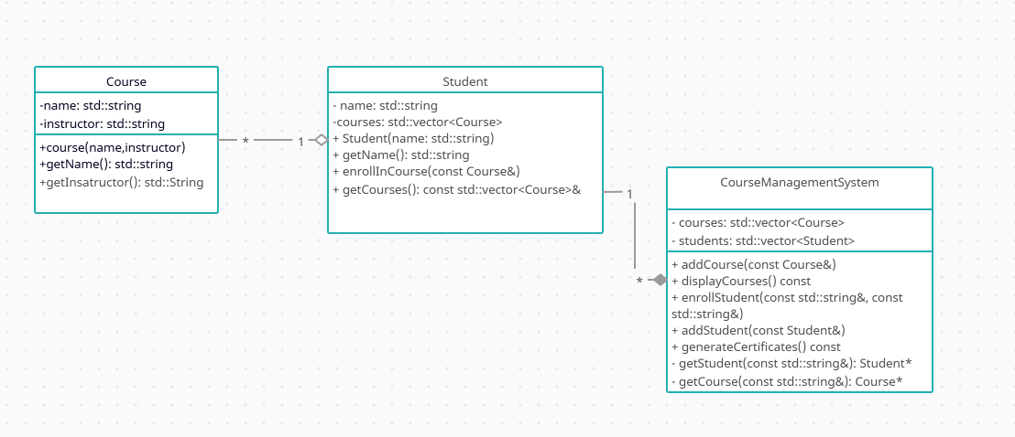

## **Technical Feasibility**

The project is technically feasible as it leverages C++, a robust programming language well-suited for system-level programming. The use of C++ ensures efficient memory management and performance. Additionally, the modular design of the system, involving distinct classes for courses, students, and the management system, allows for scalability and easy maintenance.

## **Final Outcome**

The final outcome of this project will be a C++ program capable of managing courses, enrolling students, and generating certificates automatically. The system will streamline administrative tasks, reduce errors, and save time, contributing to the overall efficiency of educational institutions.

## **Discussion and Conclusion**

The development of an automated course management and certificate generation system addresses a significant need in educational administration. By automating these processes, the system reduces the administrative burden, minimizes errors, and enhances the overall efficiency of educational institutions. The project demonstrates the potential of C++ in developing practical and impactful software solutions.

## **Future Enhancements**

Future enhancements to the system could include:

1. Integration with databases for persistent data storage.
2. Development of a graphical user interface (GUI) for ease of use.
3. Implementation of additional features such as grade tracking and course scheduling.
4. Extending the system to support online course management and digital certificate generation.

References

Banerjee, P., & Singh, G. (2016). Automated course management system for educational institutions. *International Journal of Advanced Research in Computer Science and Software Engineering, 6*(5), 123-129.

Sharma, A., & Gupta, R. (2017). Development of a course management system using modern web technologies. *Journal of Education and Practice, 8*(9), 45-52.

Khandelwal, S., & Verma, A. (2018). Implementation of an automated certification system for online courses. *International Journal of Computer Applications, 179*(23), 30-35.